SYSTEM INFORMATION TOOL

Submitted By
SAMEER MALK
(Regd. No. 2023-uok-04043)
JUNAID AKHTER
(Regd. No. 2023-uok-04040)

Session 2023-2027
Submission Date: 28th Jan, 2026
Version: 1.0
University of Kotli Azad Jammu and Kashmir
Faculty of Computing & Engineering
Department of CS&IT
SYSTEM INFORMATION TOOL
Submitted By
SAMEER MALIK
(Regd. No. 2023-uok-04043)
JUNAID AKHTER
(Regd. No. 2023-uok-04040)

A Report
Submitted in partial fulfillment of the requirements for the 5th semester project of
Operating system
In
Information Technology
Session 2023-2027
University of Kotli Azad Jammu and Kashmir
Faculty of Computing & Engineering
Department of CS&IT

Table of Contents
INTRODUCTION OF PROJECT 1
1. PROJECT OBJECTIVE 1
2. FUNCTIONAL REQUIREMENTS 1
3. NON-FUNCTIONAL REQUIREMENTS 2
4. INPUT REQUIREMENTS 4
5. OUTPUT REQUIREMENTS 4
6. ASSUMPTIONS AND CONSTRAINTS 4
7. CONCLUSION 4
8. REFERENCE EXISTING SOFTWAR 5

INTRODUCTION OF PROJECT
In modern computing environments, computer systems consist of multiple hardware and software components such as processors, memory, operating systems, and network interfaces. For a normal user, it is often difficult to understand the internal details of a computer system without using complex commands or technical tools.

A System Information Tool is an application that provides detailed information about the system’s hardware and software resources in a simple and user-friendly way. Instead of manually checking system settings or running command-line utilities, users can easily view system information through a graphical interface.

This project is developed as part of the Operating Systems course to help students understand how an operating system interacts with hardware components and provides system-level information to applications.

1. PROJECT OBJECTIVE
The main objective of this project is to design and implement a System Information Tool that retrieves and displays essential information about a computer system.
The specific objectives of this project are:
- To display complete information about the CPU (Processor)
- To show RAM (Memory) details such as total memory
- To provide Operating System name and version
- To display System Architecture (32-bit or 64-bit)
- To show the system’s IP Address
- To understand how operating systems expose system information to applications
- To provide a simple and easy-to-use interface for users
This project helps students gain practical knowledge of system-level programming concepts and understand how operating systems manage and share hardware information.

2. FUNCTIONAL REQUIREMENTS
Functional requirements define the features and operations that the system must perform.
2.1 CPU Information
- The system shall retrieve and display the processor name
- The system shall show CPU architecture
- CPU information shall be fetched automatically from the operating system
2.2 Memory (RAM) Information
- The system shall display total installed RAM
- The system shall retrieve memory information dynamically
- Memory information shall be accurate and system-based
2.3 Operating System Information
- The system shall display the operating system name
- The system shall show OS version details
- The system shall provide system type information
2.4 IP Address Information
- The system shall retrieve the current IP address
- The system shall display the local network IP
2.5 User Interaction
- The system shall provide buttons for different information modules
- On button click, the respective information shall be displayed
- Output shall be shown clearly on the screen

3. NON-FUNCTIONAL REQUIREMENTS
Non-functional requirements define system quality attributes and constraints.
3.1 Usability
- The system shall have a simple and user-friendly interface
- The system shall be easy to use for beginners
3.2 Performance
- The system shall provide quick response time
- Information retrieval shall be efficient
3.3 Reliability
- The system shall provide accurate system information
- The application shall not crash during normal use
3.4 Portability
- The system shall run on Windows Operating System
- No external dependencies shall be required
3.5 Security
- The system shall only read system information
- No modification of system settings shall be allowed

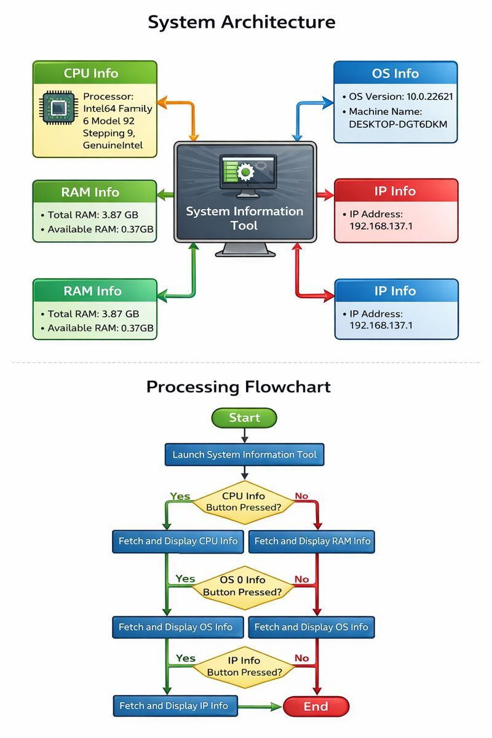

4. INPUT REQUIREMENTS
- The System Information Tool does not require complex user input.
Inputs include:

- Button clicks for selecting information type (CPU, RAM, OS, IP)
The system automatically collects data from the operating system without
requiring manual data entry.

5. OUTPUT REQUIREMENTS
The system shall display the following outputs:
- CPU details (Processor name and architecture)
- RAM details (Total memory)
- Operating System name and version
- System type (32-bit / 64-bit)
- IP Address
All outputs shall be displayed in text format on the application screen in a clear and readable manner.

6. ASSUMPTIONS AND CONSTRAINTS
Assumptions
- The user is using a Windows-based system
- The system hardware is functioning correctly
- The user has basic computer knowledge
Constraints
- The application is limited to Windows OS
- Internet connection is not required
- The system only provides read-only information

7. CONCLUSION
- The System Information Tool is a useful and educational application that provides essential information about a computer system in a simple way. This project successfully demonstrates how an operating system interacts with hardware and provides system-level information to applications. It also helps students understand practical concepts of operating systems through real-world implementation.

8. REFERENCE EXISTING SOFTWAR

- Operating Systems Course Notes
- Microsoft Windows Documentation
- Online technical resources

